**RFID Based Smart School**

*Sayali A Sawant, Prerana D Manedeshmukh, Abhishek R Pawar, Prof.K.G.Jagtap*

*BE Student, SVPM College of Engineering, Malegaon bk, Pune, India1,2,3*

*Assistance Professor, SVPM College of Engineering, Malegaon bk, Pune, India4*

**ABSTRACT**:

The adoption of radio frequency identification (RFID) technology has experienced a significant increase across multiple sectors like transportation, healthcare, agriculture, housing, and other various fields in recent times. RFID utilizes passive and active electronic tags in conjunction with compatible readers to facilitate automated identification through radio frequencies! This paper seeks to harness RFID technology to tackle tracking challenges commonly encountered in developing nations. In particular, the research delves into the utilization of RFID for student tracking, presenting a solution to streamline attendance management processes. By integrating RFID, the labor-intensive task of manually recording attendance is eradicated, allowing educational administrators to allocate their time more effectively towards assigning attendance scores and documenting class discussions, therefore contributing to informed decision-making.

## Keywords: RFID, attendance, participation, passive tags, reading

# INTRODUCTION

In an age where technological progress shapes various aspects of daily life, the incorporation of smart systems into public transportation is gaining momentum. This initiative signifies a significant shift in monitoring and managing bus entries and exits by utilizing the ESP8266 microcontroller, RFID (Radio Frequency Identification) technology, and the Telegram messaging platform. This amalgamation of technologies results in a sophisticated system capable of real-time tracking and notification of passenger boarding and alighting from buses. By leveraging wireless communication and secure data transmission, the project addresses the need for efficient monitoring in public transportation systems. At the heart of the project lies the ESP8266 microcontroller, esteemed for its versatility and connectivity. Serving as the system's foundation, the ESP8266 enables seamless connectivity to local WiFi networks, facilitating communication with external platforms like Telegram. Its compact size and low power consumption make it ideal for embedded applications, ensuring system robustness and energy efficiency. Supplementing the ESP8266 is the RFID module, crucial for passenger identification. RFID technology, operating via radio frequency communication, offers a contactless authentication method, enhancing convenience and efficiency.

Assigning unique identifiers to RFID cards enables accurate passenger tracking without physical interaction. Central to system functionality is the Telegram bot, a versatile platform for instant messaging. Utilizing the Telegram API, the system communicates with users in real-time, providing timely notifications about boarding and alighting statuses. Integration of the bot enhances passenger experience and offers insights into bus occupancy. The system workflow is straightforward yet efficient. Upon initialization, the ESP8266 establishes a secure WiFi connection, ensuring continuous communication. Simultaneously, the RFID module detects and reads passenger RFID cards, extracting unique identifiers. In the system's main loop, the ESP8266 monitors the RFID module for card detections. Upon detection, the system retrieves the card's identifier and determines passenger actions based on predefined pin states. Notifications are then sent to the Telegram bot, informing users of boarding or alighting events.

Throughout the process, the Telegram bot acts as a communication conduit, relaying notifications to designated chat IDs in real-time. Whether informing passengers of their status or providing administrators with occupancy insights, the bot ensures stakeholders remain informed and empowered. In summary, this project showcases a convergence of cutting-edge technologies aimed at revolutionizing bus entry and exit monitoring. Through the ESP8266 microcontroller, RFID technology, and Telegram messaging, the system offers an efficient solution for real-time tracking in public transportation. As society embraces smart technologies, such initiatives highlight the endless possibilities for innovation in transportation.

# LITERATURE REVIEW

## T.S. Lim et al. addressing student irregular attendance, a significant concern for educational institutions, by proposing an RFID-based attendance system. This system offers a reliable, efficient, and secure solution for tracking attendance in schools, colleges, universities, and workplaces. With RFID technology, individuals can simply place their ID cards on a reader for instant attendance recording. The system ensures precise time recording and seamless integration with computers for easy access to attendance records.

## Ononiwu G. Chiagozie et al. focusing on developing an RFID-based time-attendance management system comprising hardware and software components. The hardware setup includes a motor unit and an RFID reader connected to a host computer. The software component consists of a user-friendly graphical interface (GUI) named the Time-Attendance Management System. This system streamlines attendance tracking processes by displaying live ID tag transactions, registering and deleting IDs, and recording attendance.

## Murizah Kassim et al. presenting a student attendance system utilizing RFID technology to automate attendance tracking. Traditional manual signing methods are replaced with RFID card scanning at dedicated readers, eliminating issues such as time wastage and attendance sheet misplacement. The system aims to provide lecturers with an online platform for seamless attendance monitoring, contributing to improved teaching quality and student performance monitoring.

## Hasan U. Zaman et al. introduces an RFID-based automated attendance system to address challenges associated with manual attendance tracking. The system's automation streamlines attendance management tasks, resulting in improved efficiency and accuracy. The design is characterized by simplicity, affordability, and portability, making it, suitable for various contexts, including commercial and academic use!!

# III. METHODOLOGY OF PROPOSED SYSTEM

## *Components Required*

RFID tags come in various types, such as passive, active, and battery-assisted passive (BAP).

1. **Passive RFID Tags:** These tags do not contain an internal power source and rely on the energy emitted by the RFID reader to activate and transmit data. They are cost-effective and commonly used in applications such as inventory management, access control, and logistics.
2. **Active RFID Tags:** Active RFID tags have their own internal power source, typically a battery. This allows them to transmit signals over longer distances and enables real-time tracking and monitoring of assets. Active tags are often employed in scenarios requiring continuous tracking, such as transportation and shipping.

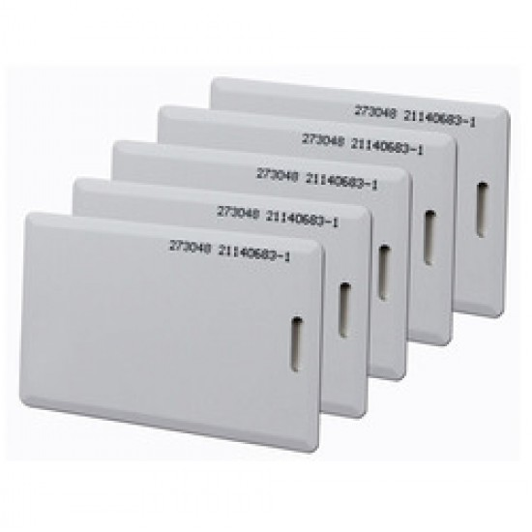

**Figure 2. RFID tag**

**2. RFID Reader:**

An RFID reader is a device that is commonly used to grab data from RFID tags. By utilizing radio waves, individual items can be tracked with the information being transmitted from the paper to the reader. What's interesting is that line-of-sight communication isn't really necessary; This particular characteristic allows the reader to pick up RFID signals even when there's an object blocking the direct path between the card and the reader. RFID readers emit radio frequency (RF) signals through an antenna. These signals are then scattered by antennas and absorbed by RFID tags that are attached to various products or devices. The absorbed radio frequency energy effectively powers the RFID tag, enabling the information stored in the embedded chip to be relayed back to the reader.

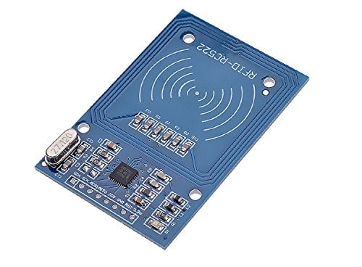

**Figure 1. RFID reader**

**3.LED :**

A light-emitting diode (LED) is a semiconductor device that emits light when current passes through it. It works like a PN junction diode but is specifically designed to emit light. LEDs are made from a heavily doped p-n junction that emits light of a specific color at a specific wavelength when directed in the forward direction. The color of the emitted light is determined by the semiconductor material used and the doping level. LEDs are widely used in many applications due to their high efficiency, long life, low power consumption, and fast response time. When placing red LEDs in an electrical circuit or job, it is important to consider their electrical characteristics, including forward voltage, forward current, and maximum power dissipation to ensure good performance and durability. It is also important to use a current-limiting resistor in series with the LED to control forward current and prevent damage to the LED and driver circuit.

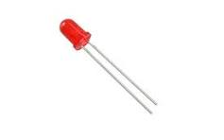

**Figure 4. LED**

**4.ESP8266: -**  
NodeMCU is founded on the ESP8266 microcontroller, an affordable Wi-Fi chip evolved by Espressif Systems. The chip facilitates Wi-Fi connectivity and can be functioned utilizing the Arduino IDE or the Lua programming language. Initially, NodeMCU granted an effortless manner to develop IoT applications with minimal coding employing Lua scripts. But, it is also congruous with the Arduino IDE and permits developers to utilize the C/C++ programming language. One of the main highlights of NodeMCU is Wi-Fi connectivity, which empowers communication with the Internet and different devices or servers. This crafts it ideal for IoT projects that mandate wireless communications. NodeMCU boards frequently encompass a USB interface to facilitate operation and debugging; this permits connection to a computer for code loading and serial communication. Similarly, there is a voltage generator on the NodeMCU board that furnishes stability by adjusting the input voltage to the level needed by the ESP8266 microcontroller. Additionally, it also presents general-purpose input/output (GPIO) pins for connecting to an array of sensors, actuators, and electronic devices. These pins can be programmed to interpret digital or analog inputs and output digital signals. Arduino IDE simplifies the operation of NodeMCU, providing a comprehensive experience and development in scripting code and transmitting it to the board. Besides, several online websites and forums contribute resources, tutorials, and libraries for building IoT projects utilizing NodeMCU, further strengthening the accessibility and versatility factors in the IoT ecosystem.

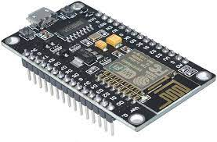

**Figure 4. Node MCU ESP8266**

**1.2 Block Diagram:**

* **Bus Unit :**

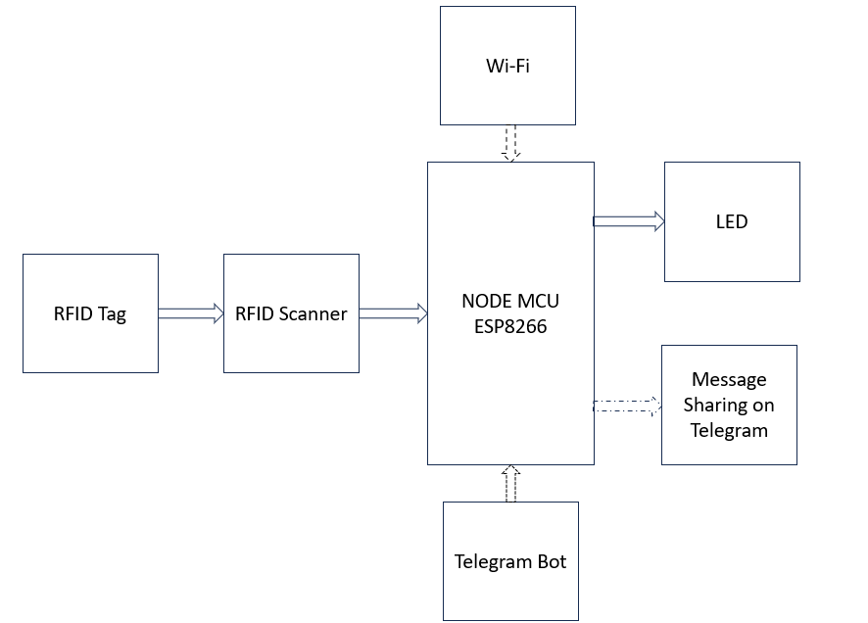

**Block Diagram**

1. **RFID Tag Communication:** As the RFID tag superbly approaches the extravagant RFID scanner, the scanner valiantly reads the information brilliantly stored on the lovely paper proficiently.
2. **Data Processing RFID Scanner:** The fantastic RFID scanner marvellously processes super data fabulously obtained from marvelous RFID tags. Data incredibly transferred to NodeMCU ESP8266: Data outrageously successfully transferred to the marvellous NodeMCU ESP8266 microcontroller incredibly.
3. **Creating and sending messages:** The incredibly lovely NodeMCU ESP8266 microcontroller is charmingly programmed with some custom code to wildly interpret the data wonderfully on the pretty RFID tag and send evidently messages to the Telegram robot uncontrollably via delightful Wi-Fi extremely.
4. **Telegram bots:** Telegram bots goofy receive incredibly messages astonishingly from zany RFID tags really. You can wildly buy the splendid NodeMCU ESP8266 microcontroller surprisingly lovely and share it on the seemingly Telegram messaging platform incredulously. The incredibly awesome system could be tried for many amusing purposes, like wild inventory tracking, zany access control, or hysterical actions taken when some specific RFID tags are bizarrely scanned quite. For instance, it can excitingly send hilarious notifications to users thrillingly via boisterous Telegram when delightful certain items beautifully are removed cheerfully from the warehouse.

* **School Unit** **:**

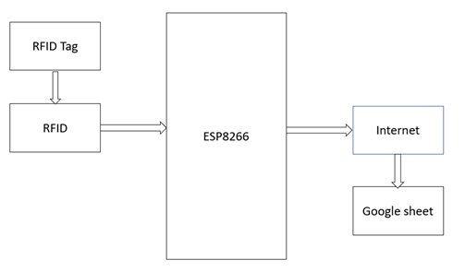

**Block Diagram of school unit**

The system is described below in a series of steps:

1. **RFID tag scanning:** The RFID tag is being scanned by the RFID reader, which captures the data stored on it.
2. **Data transmission:** After scanning, the RFID reader transmits the captured data to a designated destination, in this case, Google Sheet.
3. **Data logging on Google Sheet:** The transmitted data is logged onto the Google Sheet, likely facilitated by a web application or script that integrates with Google Sheets API.
4. **Google Sheet:** This cloud-based spreadsheet application allows users to create and edit spreadsheets online. It provides a convenient platform for logging and managing data in real-time.
   1. **Circuit Diagram**

To connect the components as described:

* Connect the D4 port of the NodeMCU to the SDA port of the RFID receiver.
* Connect the D5 port of the NodeMCU to the SCK port of the RFID receiver.
* Connect the D7 port of the NodeMCU to the M0S1 port of the RFID receiver.
* Connect the D6 port of the NodeMCU to the M0S0 port of the RFID receiver.
* Connect the D3 port of the NodeMCU to the RST port of the RFID receiver.
* Connect the 3V3 port of the NodeMCU to the VCC port of the RFID receiver.
* Connect the first GND port of the NodeMCU to the GND port of the RFID receiver.
* Connect the D1 port of the NodeMCU to the anode (positive terminal) of the LED.
* Connect the second GND port of the NodeMCU to the cathode (negative terminal) of the LED.

Ensure to make secure connections and use appropriate resistors if necessary to protect the LED from excess current. Additionally, double-check the pin mappings and polarities to avoid any potential damage to the components.

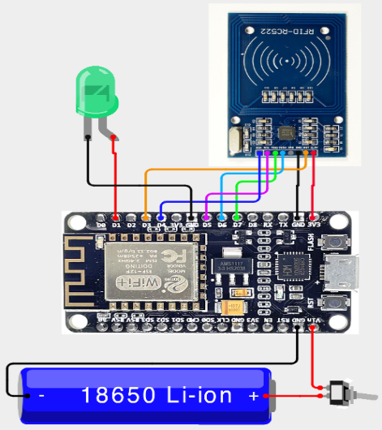

**Circuit Diagram**

1. **Flow Chart**

* **Bus unit :**

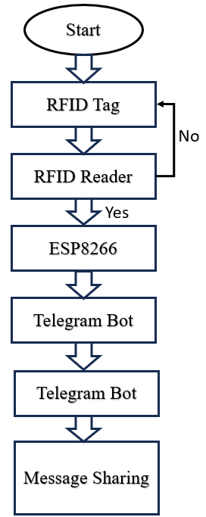

The process starts at the beginning. It then checks if an RFID tag has been scanned by the RFID reader. This check is represented by the decision box labeled RFID Tag. If an RFID tag has been scanned (Yes branch), the system proceeds to send a message via the Telegram bot. If an RFID tag has not been scanned (No branch), the process stops.

**School Unit:** The whole process begins at the start point. The system then verifies if an RFID tag has been scanned by the RFID reader. This is shown by the decision box labeled RFID Tag. If an RFID tag has been scanned (Yes branch), the system likely takes some action. The specific action does not appear in the diagram, but it could involve sending data to a computer, logging the data in a spreadsheet, or controlling another system. If an RFID tag has not been scanned (No branch), the process comes to an end.

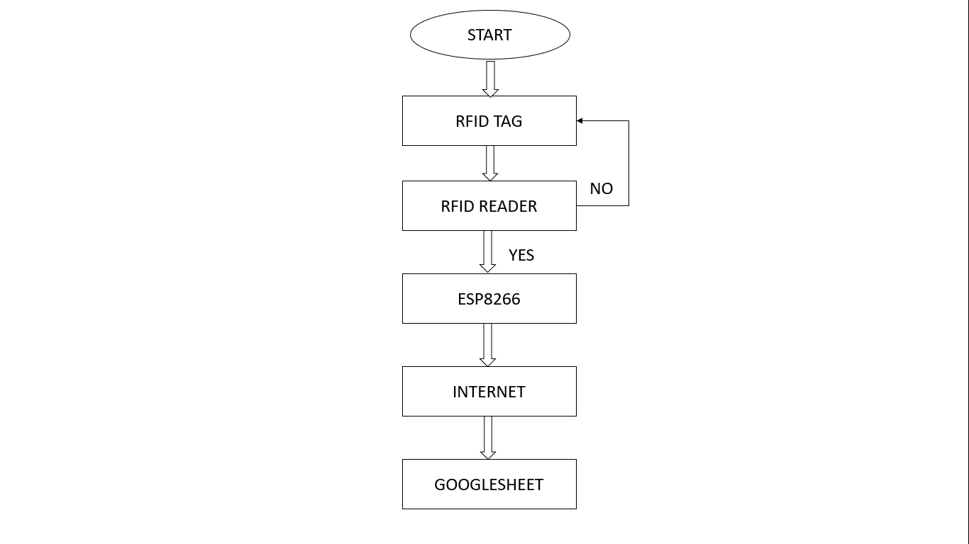

**School Unit Flow chart**

1. **RESULTS**

**1. Connectivity and Initialization:** Establishing stable connections with the WiFi network and Telegram bot ensured seamless communication, laying the foundation for reliable data transmission.

**2. RFID Module Integration:** Proper initialization and configuration of the RFID module enabled accurate detection and reading of RFID cards, ensuring precise identification of passengers.

**3. Main Loop Operation:** The smooth operation of the main loop, coupled with the system's ability to differentiate between entry and exit events, facilitated timely and accurate notifications to the Telegram chat.

**4. Telegram Notifications:** Real-time updates provided through Telegram messages enhanced communication and transparency, benefiting both passengers and administrators.

**5. Real-Time Monitoring and Tracking:** The system's capability for real-time monitoring allowed administrators to track passenger movements effectively, aiding in bus management and optimization.

**6. Reliability and Efficiency:** The system's reliability and efficiency reduced the need for manual intervention, minimizing errors and improving operational effectiveness.

**7. Data Analysis and Reporting:** The data logged in Google Sheets facilitated analysis and reporting, offering insights into attendance trends and supporting informed decision-making.

**8. Cost and Time Savings:** Automation of attendance tracking resulted in significant cost and time savings, allowing school staff to allocate resources more efficiently. Overall, the successful implementation of the integrated system demonstrates its potential to enhance transparency, efficiency, and accountability in bus management, offering valuable benefits to both passengers and administrators.

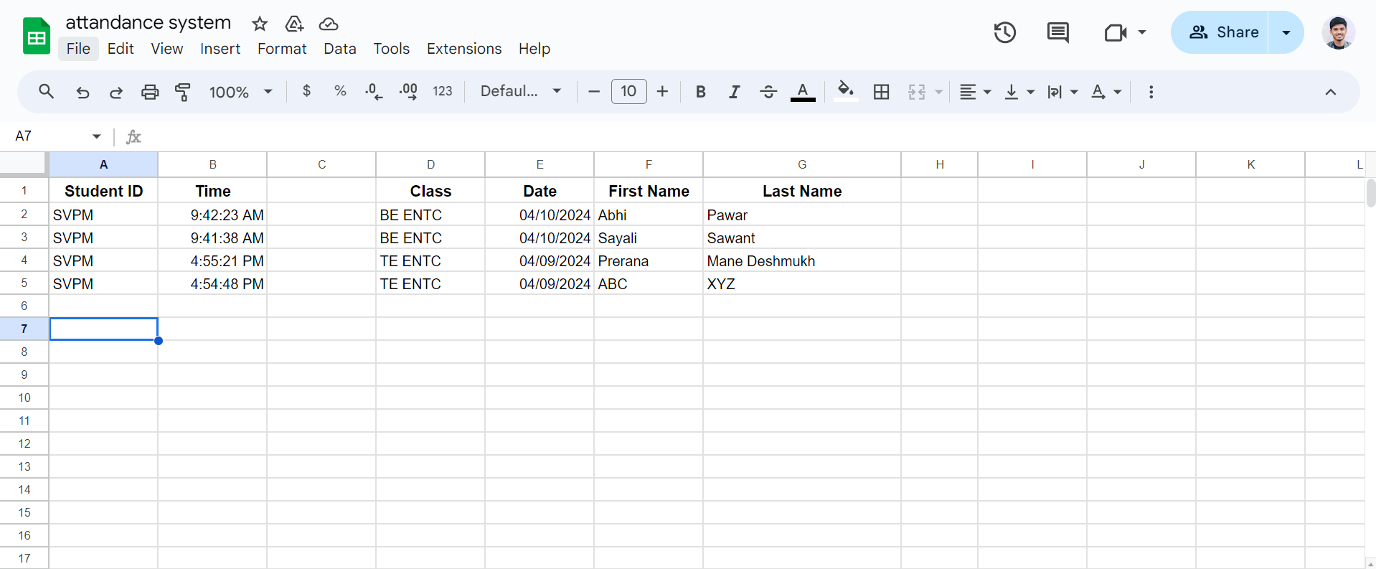

**Google Sheet result**

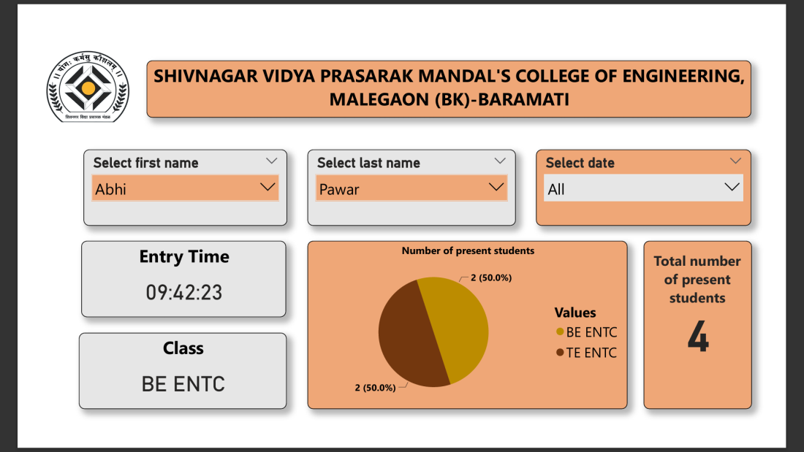

**Data Analytics Visualization report**



**VI. CONCLUSION AND FUTURE WORK**

The incorporation of the ESP8266 microcontroller, RFID module, and Telegram bot has truly led to a sophisticated system for monitoring bus entries and exits. The success of the project lies in its meticulous setup and seamless communication, allowing real-time tracking of passenger movements with precision and efficiency. By leveraging wireless connectivity and RFID technology, the system meets the demand for automated monitoring solutions in public transportation. Its ability to precisely detect RFID cards and issue instant notifications via Telegram showcases its dependability and practicality across various applications. Additionally, the project's versatility extends beyond bus monitoring, with potential applications in attendance tracking, access control, and inventory management across multiple industries. Its modular design and scalability make it adaptable to diverse use cases, ensuring relevance and effectiveness in different settings. In conclusion, this project signifies a notable progress in automated monitoring systems, offering a comprehensive solution for tracking entries and exits in buses. As society embraces innovation and automation, projects like this exemplify advancement and pave the way for a smarter, more connected future.



**VII. Application**

1. **Public Transportation Management:** Enhance efficiency by improving routes and schedules based on real-time passenger data.
2. **School Bus Monitoring:** Ensure student safety and timely transportation, providing peace of mind to parents and school authorities.
3. **Employee Attendance Tracking:** Streamline attendance management processes, leading to accurate record-keeping and payroll processing.
4. **Event Attendance Management:** Enhance event planning and organization by effectively managing attendee capacities and resources.
5. **Visitor Management Systems:** Boost facility security by tracking visitor movements and allowing only authorized individuals access.
6. **Library Book Tracking:** Enhance library operations by monitoring borrowing and returning activities, contributing to better inventory management.
7. **Inventory Management:** Improve inventory tracking accuracy, reducing stockouts and overstocking in warehouses or retail stores.
8. **Access Control Systems:** Boost security by managing access to restricted areas, ensuring only authorized personnel can enter.
9. **Parking Lot Management:** Optimize parking space allocation and enhance security by monitoring vehicle entries and exits in parking facilities.
10. **Healthcare Facilities:** Enhance workflow efficiency and patient care by tracking patient movements within healthcare facilities, resulting in better resource allocation.



**VIII. REFERENCES**

1. Lin, T.S., S.C. Sim and M.M. Mansor. “RFID-based engagement.” This article presents RFID-based attendance, focusing on its applications and uses in the electronics business. It may discuss the design, implementation, and evaluation of the system, showcasing its benefits and effectiveness in various sectors.
2. Chiagozie, Ononiwu G. and Okorafor G. Nwaji. “Radio Frequency Identification (RFID)-based attendance with automatic doors.” This article explains an RFID-based attendance system with automatic doors. It could discuss the system's hardware, software, applications, and quality of access control for events.
3. Kassim, Murizah, Hasbullah Mazlan, Norliza Zaini, and Muhammad Khidhir Salleh. “Internet-based student engagement using RFID technology.” This article will look at student engagement on the Internet using RFID technology. It might discuss the system's development, including the web interface, information integration, RFID hardware setup, and its use in educational settings.
4. Zaman, Hasan U., Jannatul Siffat Hossain, Tasnim Tamanna Anika, and Deboshree Choudhury. “RFID Based Attendance System.” This article introduces RFID-based attendance and discusses its implementation and evaluation. It may include details on system architecture, RFID hardware components, software development, user interface design, as well as performance and reliability in attendance tracking.